BEEPETMART TECHNOLOGY
BeePetMart Technology
- Company Name: BeePetMart Technology
- Location: Indonesia
- Business: ERP Integration & Omnichannel Middleware
- Website: https://beepetmart.com
Description
BeePetMart Technology develops middleware and ERP integration systems designed to help e-commerce sellers manage multi-marketplace operations efficiently.
Product and Platform
An integration platform that connects ERP systems with marketplaces including:
- Lazada
- Shopee
- Tokopedia
- TikTok Shop
Main capability:
- Product synchronization
- Inventory management
- Order synchronization
- Price management

System and Architecture

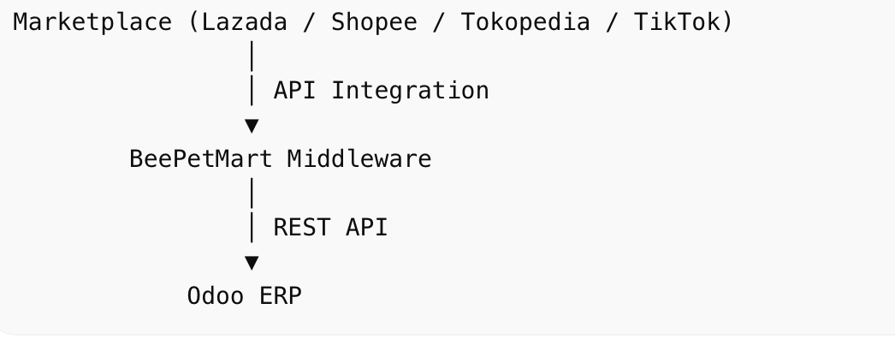
Benefits for Sellers
• Centralized order management
• Real-time inventory synchronization
• Reduce manual work
• Multi marketplace management

